
Greenfields Day Nursery Prospectus
Greenfields Day Nursery is a small village nursery, established in October 2000 by Susan McGeoch, who is the Owner and Manager to this day. The ethos of the nursery is to provide high quality, reliable childcare for families. A place where children feel safe and nurtured with staff who ensure the standard of care they provide is their top priority. Aside from the obvious desires of providing a fun and caring place for children to grow, we aim to provide continuity of staff which is often difficult in the nursery environment. We aim to provide a rewarding place for the staff to be, as well as the children. ‘Happy Staff makes for Happy Children’.
At Greenfields Day Nursery, you’ll find a safe, nurturing and loving environment where your child’s individual skills and abilities are encouraged to grow and flourish. All children are supported to allow them to become confident, happy, and independent little ones who are celebrated for who they are.
We are very proud to be rated ‘Outstanding’ by Ofsted at our last two inspections. You can read about our inspections by clicking the link below.
https://reports.ofsted.gov.uk/provider/16/221635
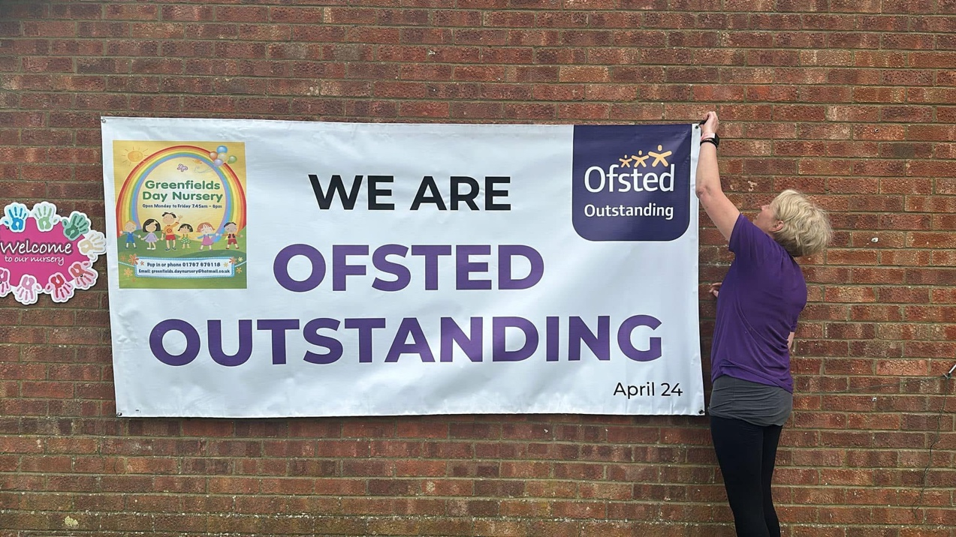

At the nursery we do not advertise, but pride ourselves on word of mouth recommendations.
We have a facebook page and a website.
https://www. facebook.com/Greenfields-Day-Nursery-106131378560095/
https://www.greenfieldsdaynursery.co.uk/

If you have any questions regarding anything in this Prospectus or would like some more information, or to arrange a visit please call Susan on 01767 679118 or email greenfields.daynursery@hotmail.co.uk.

Our Nursery
The nursery is situated on the Sports Field in the Sports Pavilion, surrounded by an open field which we use daily throughout the year. We are registered for 35 children between the ages of 6 months and 4 years.
The nursery is open Monday to Thursday 7.45am- 5.45pm and Friday 7.45am-5.30pm. We are open all year except for Bank Holidays and a short break over the Christmas period.

Our Aim
We aim to provide the children with a warm, safe and stimulating environment where staff can assist the children with learning through play. We have a wide range of toys and activities to encourage this, constantly growing our collection to explore. You will find pictures of some of our most popular activities on the last page of this document.

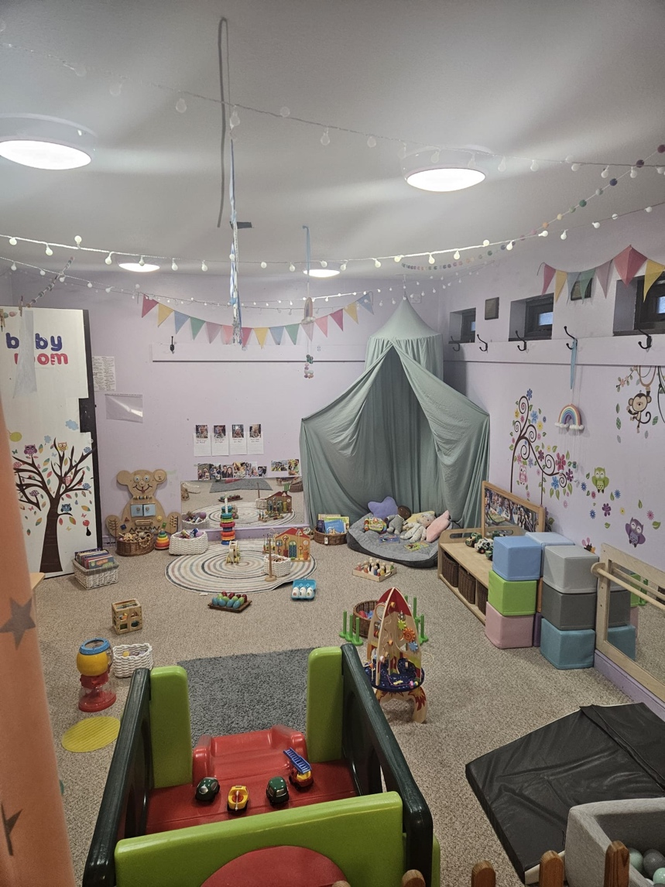
Baby room
Our baby room can take up to 6 babies with 2 members of staff. It is a bright and colourful room with lots of wooden toys, books and equipment to help the babies learn through investigation. Staff set up messy play, music, sensory and singing sessions throughout the week, and arrange their planning based on what the children enjoy.
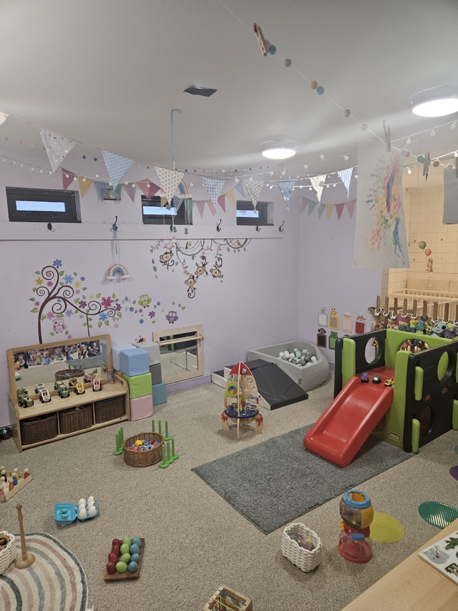

BABY ROOM
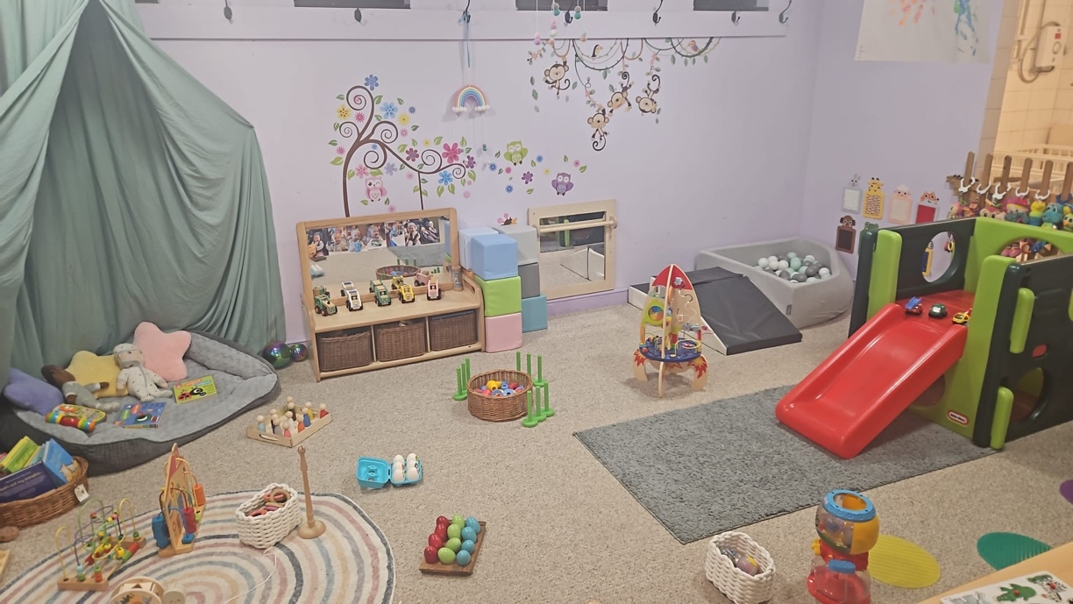

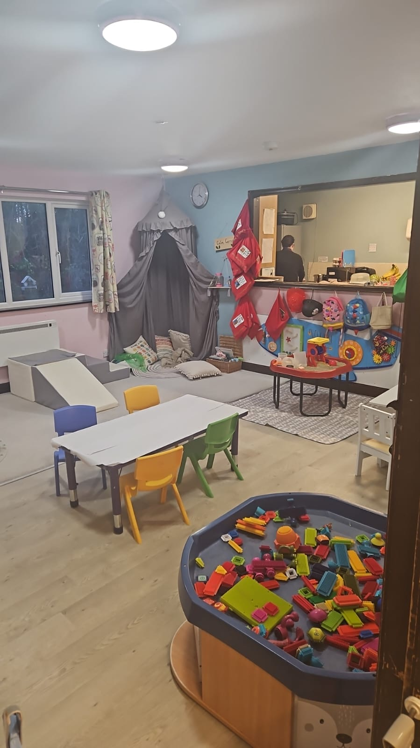
Toddler room
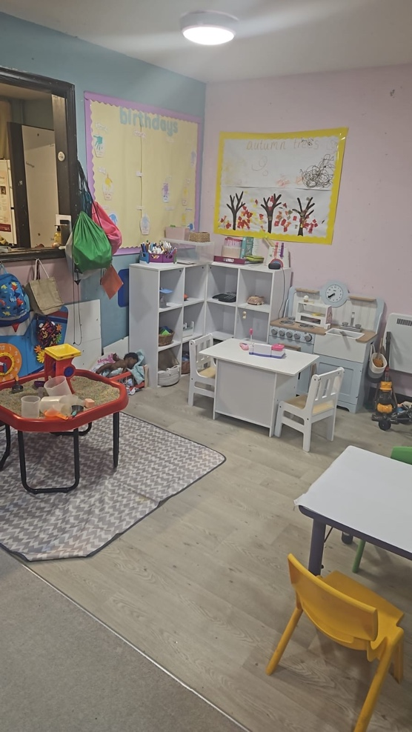
Our toddler room is designed for toddlers to 2.5yr olds. This room is well equipped to keep these children entertained by providing various activities including singing and story bags, sensory and messy play, arts and crafts, colourful and engaging displays, as well as role play and imaginative play areas to discover the world we live in, and learn about the people who help us.

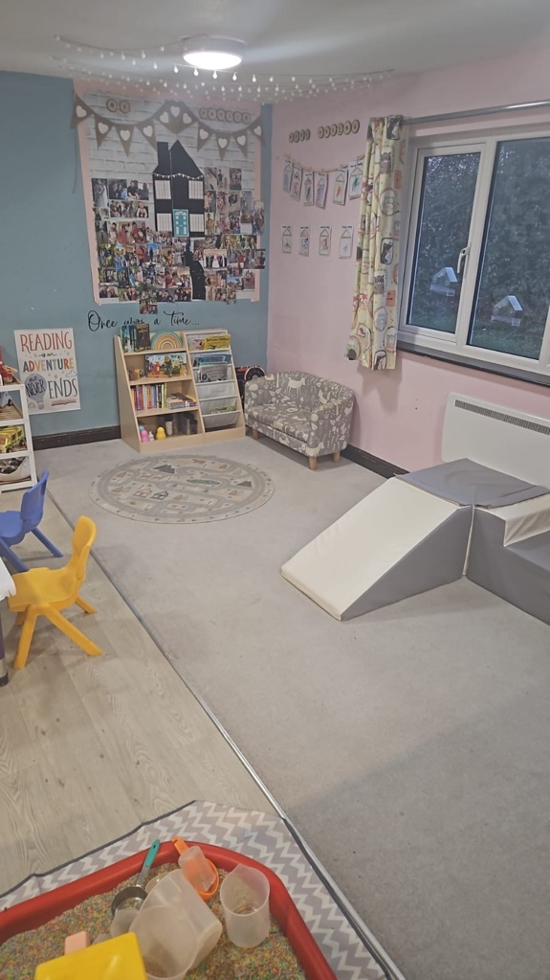
TODDLER
ROOM

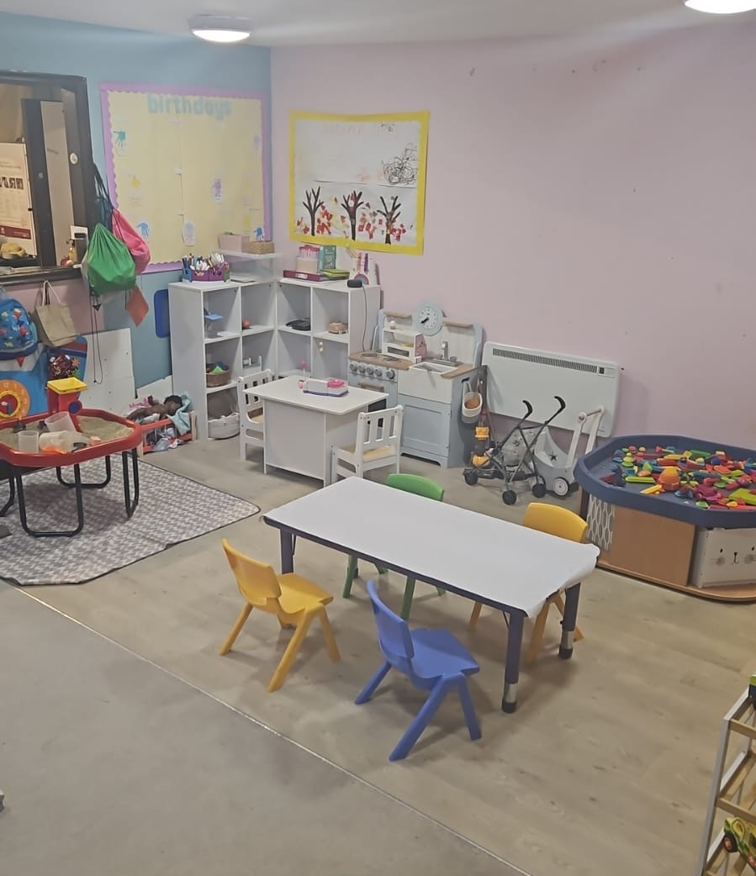

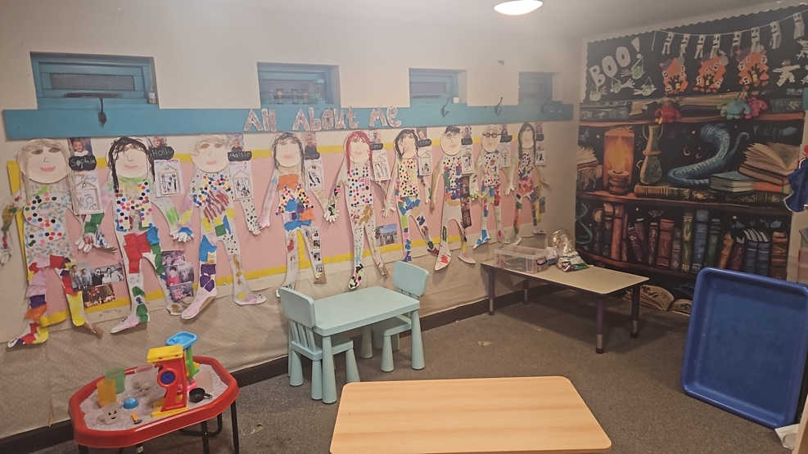
Pre-school room
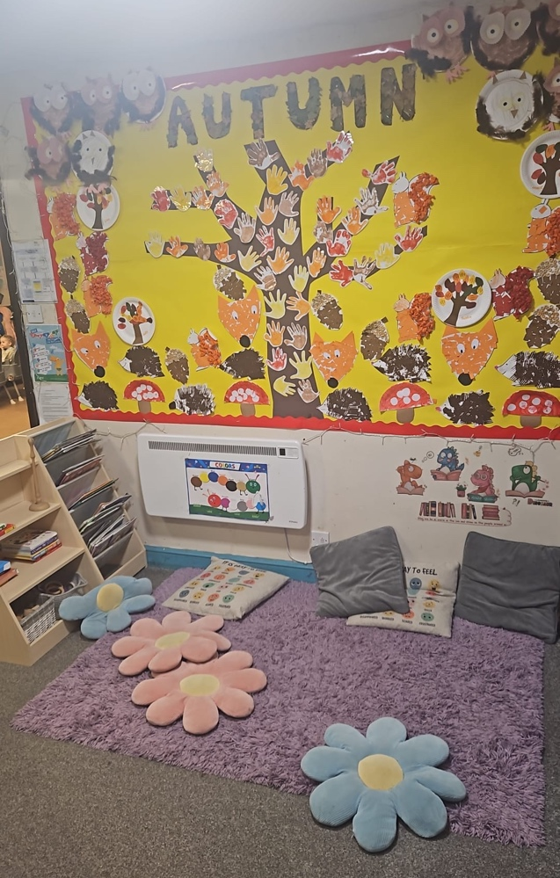
Our pre-school room welcomes children from 2.5 to 4yrs old. We have 2 pre-school room coordinators allowing the children to be split into 2 groups, based on their age. This room has structured activities to enable children to be taught in a way that prepares them for school. The nursery accepts the pre-school funding of either 11.4hrs or 22.8hrs a week, spread over 51 weeks a year. The staff separate the children into groups during group sessions, and for these sessions the younger group will use the messy area which is set up for them. This area is also used during open play in the pre-school room, giving the children more space.
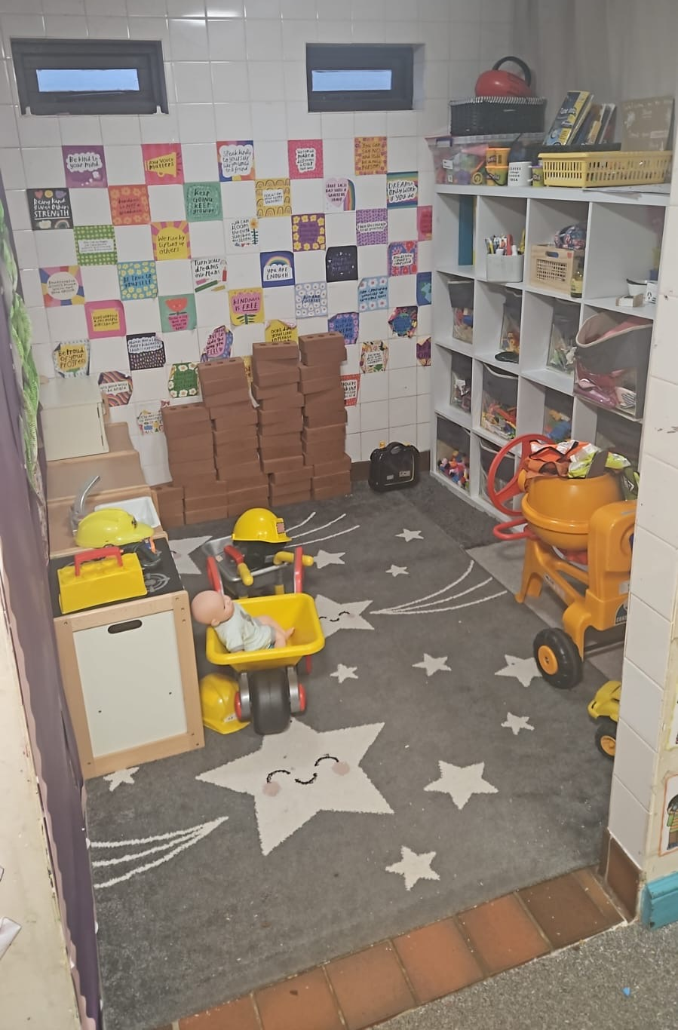

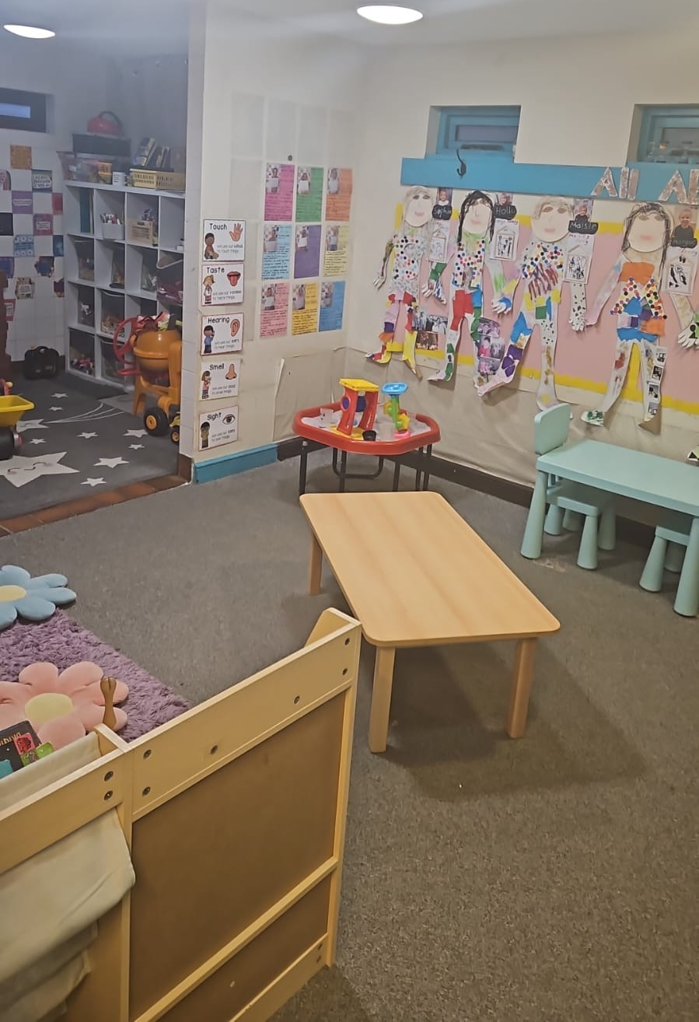

PRE-SCHOOL
ROOM

Garden area
Our garden area is split into 2 sides by a fence, this ensures the toddlers and babies have a safe play environment. However, the children from each side can still see each other playing and communicate through/over the fence. Each area has age-appropriate play equipment that still challenges them. There is a sand pit in each garden, and the children have construction and art activities in the garden every day too. We are very lucky to have the open field outside of our garden which we utilise on a daily basis with all ages, allowing them to run freely in the fresh air.
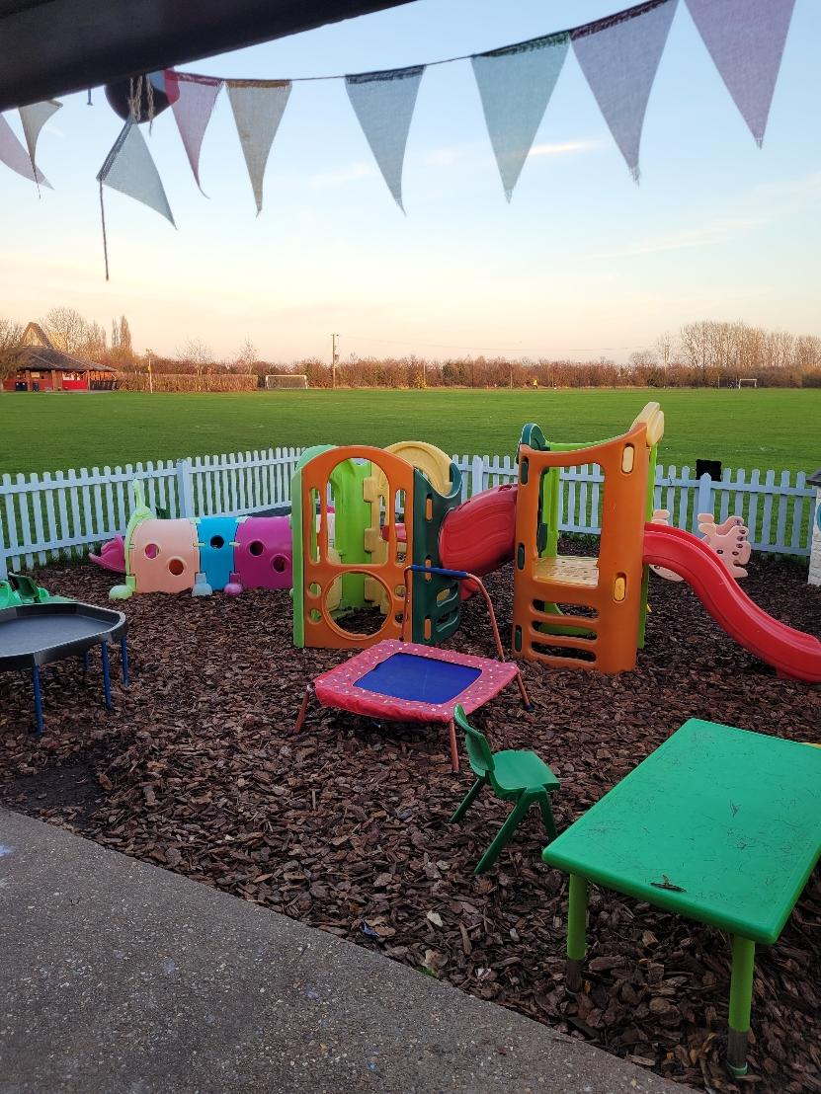

Toddler and baby garden area
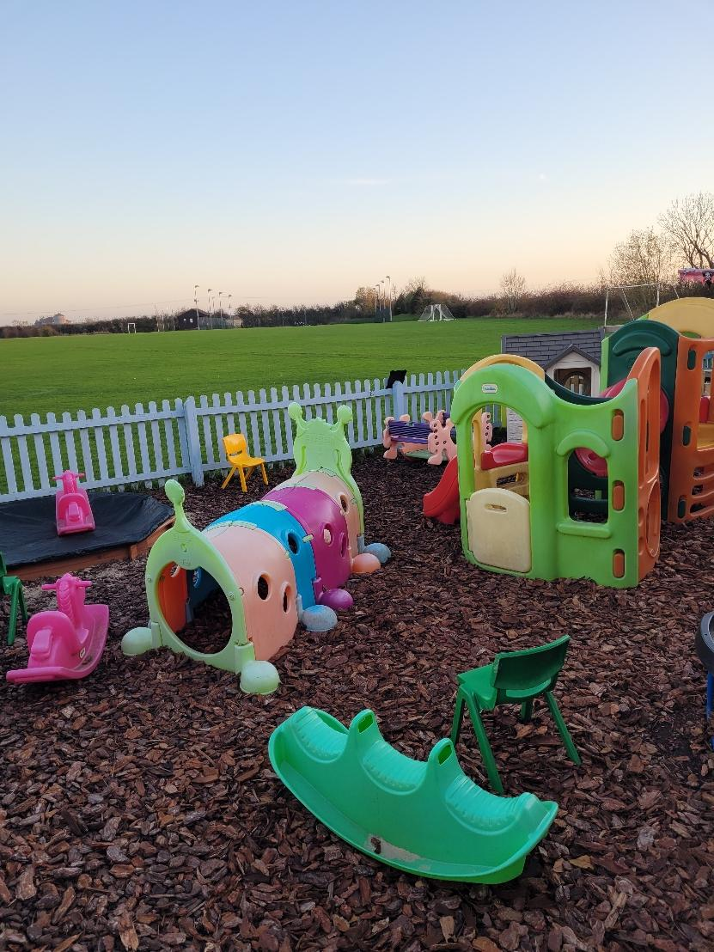

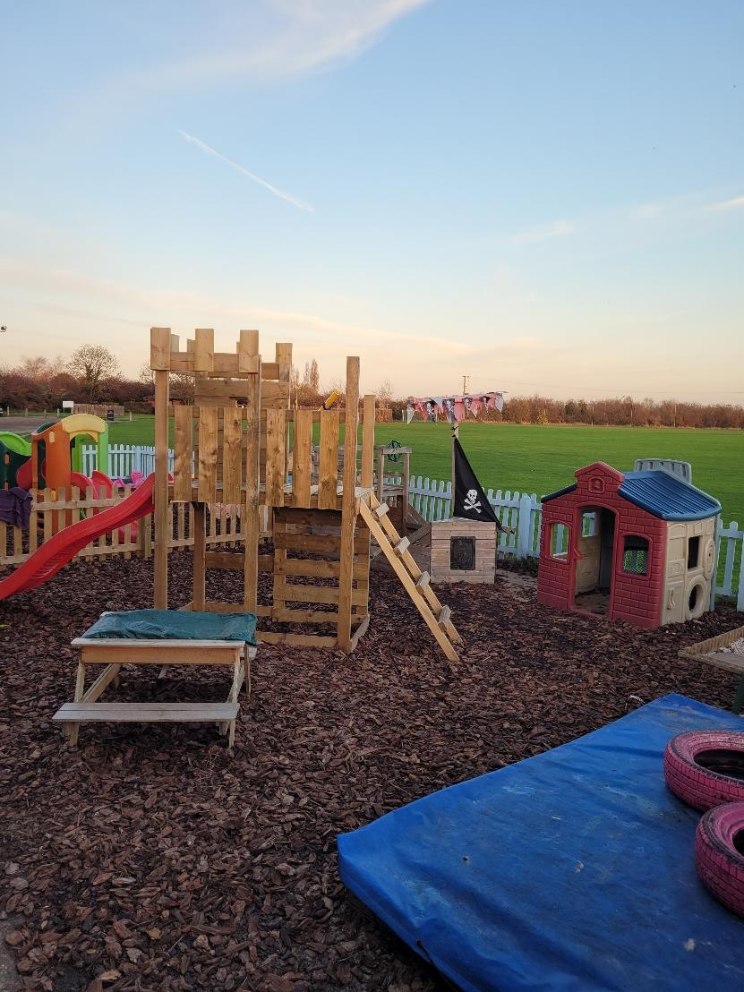
Pre-school garden area

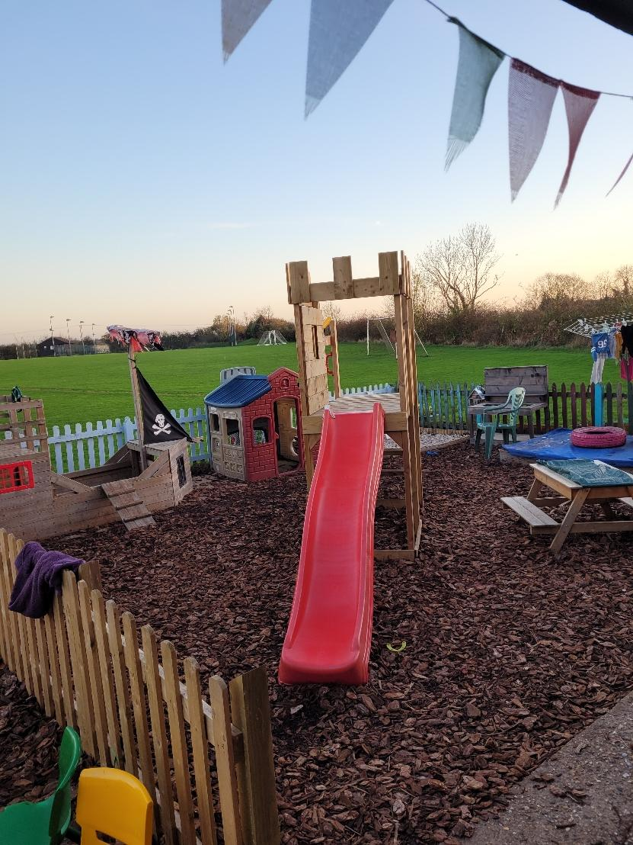

Meals
At the nursery we prepare fresh meals for the children. We have a 3-week running menu which is available to view during a nursery visit. Tesco deliver fresh meat, fruit and vegetables twice weekly to ensure the food we provide is of the highest possible standard.
We hold our 5-star food hygiene rating and have multiple staff members who are food hygiene trained and qualified.
Meal times throughout the day:
7:45-8:30am Breakfast (A selection of cereals- Cheerios, Shreddies, Cornflakes, Multigrain Boulders, Ready Brek or Weetabix)
!0:00am Morning snack (Either 2 choices of fruit, Cheese and crackers or Toast – all served with milk/water)
11:45am- Lunch (Hot meal cooked on the premises each day)
2:45pm-Afternoon snack (Biscuit served with milk/water)
4:00pm- Tea (Light tea of either sandwich thins, scrambled egg, beans on toast, filled wraps, savoury muffins and toasted bagels with toppings – served with vegetable sticks or fruit and a yoghurt/homemade fruit cake)

Weaning babies
We ask that parents bring a pot of formula milk and bottles which we sterilise when needed. Breast fed babies milk is kept in the fridge, or freezer, until it is used.
We will happily puree fruit and vegetables for newly weaning babies or adapt our food to accommodate them as they move to whole, more solid foods.

Staffing
Staff ratios are:
1:3 = under 2years
1:4 = 2 -3years
1:8 = 3years+
We are lucky to have a low turnover of staff in the nursery and lots of our staff have been with us for over 5 years. We are first aid trained as a group and encourage all new staff to carry this out too. All staff are DBS checked.

Clothing
We ask that the children are dressed appropriately for the time of year and that you do not send them in their best clothes as we do lots of messy play. We require a named rucksack for spare clothes and ask that you put a full spare set (or two) in the bag and we send bags home if they need a new set.
During summer months we ask for a named sunhat to be left at nursery, and we provide the Factor 50 Ambre Solaire/Nivea sun cream.
During Winter months we ask for a waterproof onesie for the babies and toddlers and waterproof trousers for the pre-schoolers so toilet visits are easier when outside play is in progress. Each child needs a named winter coat, hat and gloves for outdoor adventures when the weather is chilly.
Policies
All the nursery’s policies are available on the nursery website which is linked at the top of this nursery prospectus.
Discipline
We encourage positive praise within our nursery and agree that distraction is the best way to divert a child’s attention from a difficult situation. At times, the nursery staff may feel the need for a short period of calm time and reflection.
Equal opportunities
The nursery encourages and stands by the equal opportunities and allocation of nursery places to all sectors of the community. This is regardless of race, colour, religion, disability, marital status and sexual orientation. We encourage rights in the everyday nursery life through diet and play in books, puzzles, home corner and posters showing good role models from various walks of life.
All about me
We ask all new parents to fill in an ‘All about me’ book/form. This holds lots of information about your child which helps us to give them the best care we can. Please ensure we have all up to date contact information for your child. We ask that parents provide a photo and details of anyone who is collecting their child.
Illness
The nursery reserves the right to refuse or send home a child who is poorly, as we have a responsibility to the other children. The best place for a poorly child is in their own home.
Our nursery policy is that any child who has been sick or had diarrhoea must be kept out of the nursery for 48 hours after the last bout.
Children with temperatures should not return to nursery until after 24 hours from their temperature subsiding.
Parent code of conduct
It is the responsibility of the parents to abide by the ‘Parent code of conduct’. Consequences which are because of not adhering to our code are detailed in the ‘Parent code of conduct’ document.

Nursery fees from 1st January 2025
Under 2’s 2-3 years 3 years +
Daily fee: £68.75 Daily fee: £66.55 Daily fee: £64.13
Hourly: £7.00 Hourly: £7.00 Hourly: £7.00

All daily fees include all meals

Government Funding
We accept company vouchers, HM Government tax free childcare and the government funded hours.
Our funding is stretched over 50hrs as we are open all year except for the week between Christmas and the New Year
​
Please see fis@cambridgeshire.gov.uk
Family Information Service for information on Early Years funding and other funding sources.
Funded hours can be used any time the nursery is open.
​
Government Funding:
9 months - 3 years: 22.8hrs a week
3 years: 11.4hrs a week or 22.8hrs a week
​
​Optional meal charges:
Breakfast: 50p
Lunch: £2.00
Tea: £1.00
(Parents can provide their own meals to avoid extra charges.)
Nappies are provided by parents so there is no extra charge for these.​
No deposit is charged to take up a nursery place.
​
Optional extra hours over the 11.4hrs (9mths-3yrs) /22.8hr (3+) will be charged at the hourly/daily rate.

One month’s notice is required should you want to cancel your child’s place at the nursery.
Funding is now available for all children from 9 months onwards. Applications are to be completed via gov.uk
What our parents say about Greenfields!
"Our daughter has been at Greenfields for coming up to 2 years and she could not be happier! There hasn’t been a single day she hasn’t skipped in excitedly. We could not speak more highly of Susan and every single member of the team. They all take incredible care of the kids, and form bonds that transcend life outside of Nursery. She always talks about Abbie, Megan and the other staff at the weekend. They are caring, supportive and flexible with us as a family, and as a family that doesn’t have Grandparents nearby, we don’t know what we would do without them. I’ll actually be sad when she goes to school, and I won’t keep getting to say hello!"

"We have been lucky enough to have sent both our children to Greenfields Nursery. Our eldest is now at school and still talks fondly of his time there. Our youngest is currently in the preschool room (having started at 10 months old) and is settled and content with good relationships with both the staff and other children. Many of the staff have worked at the nursery for a long time and provide a stable and loving environment. The sports field provides a great setting for outdoor adventures, and the children always seem to be taking part in an impressive variety of activities both indoors and out. I would highly recommend Greenfields Day Nursery."
​
“Just wanted to say a huge 'THANK YOU' for everything you have done for 'C' in the time that she has been with you in Nursery.
You have all helped to shape a happy, confident little girl, allowing her to have such fun and laughter whilst learning and she has had the best time! We are all going to miss you but will come back for visits!
Thank you again for everything!”

OUR FAVOURITE ACTIVITIES
